**F11 Matte Black Pull-Out Kitchen Faucet – Contemporary Style**

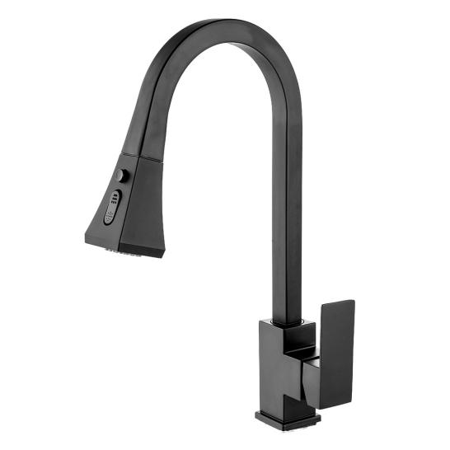

To ensure the suitability of our products for your space, please verify the measurements of the product and match them with your kitchen cabinet dimensions, and some products may not require high accuracy, but it is still important to check.

**Product Description**

Imagine the luxury of a contemporary matte black faucet in your kitchen. Made from solid stainless steel, it offers unbeatable rust and corrosion resistance. With a pull-out sprayer that has two settings, every task becomes effortless. The single lever handle and updated retraction system ensure the sprayer head always returns to its place. Keep your kitchen stylish and organized.

**Product Details**

Brand: Wonderful Kitchens

Recommended: Kitchens, Sink

Model Number: F11

Color: Black

Spray Type: Pull Down

Number of Handles: one

Included Components: Sprayer, Handle

Made in: China

Special Feature: Pull Out Sprayer, Easy to Install

Material: Stainless steel